Project Proposal
WikiLLM-Based Intelligent Knowledge Management & Question Answering System

Created By
Jayashan Manodya
Contents
1. Project Overview 3
2. Objectives 3
3. Proposed System Architecture 4
4. Proposed Workflow 5
5. Key Features 6
6. Proposed Technology Stack 6
7. Deliverables 7

Project Overview
This project proposes the development of an intelligent document understanding and question-answering system using the WikiLLM architecture. Unlike traditional Retrieval-Augmented Generation (RAG) systems that rely primarily on vector databases and semantic similarity search, this system transforms uploaded documents into a structured, interconnected knowledge base before enabling question answering.
The system will automatically analyze uploaded documents, extract entities, concepts, relationships, and factual information, and organize them into a wiki-like knowledge repository. Users will then be able to ask natural language questions, and the system will generate accurate answers based on the structured knowledge.
The objective is to demonstrate how Large Language Models can be used not only for retrieval but also for knowledge organization and intelligent reasoning.

Objectives
The primary objectives of this project are:
- Develop a document ingestion pipeline.
- Extract structured knowledge from uploaded documents.
- Generate interconnected Wiki pages automatically.
- Store knowledge in an organized, reusable format.
- Enable natural language questions answering over the generated knowledge.
- Build a scalable architecture that can support multiple documents in the future.

Proposed System Architecture
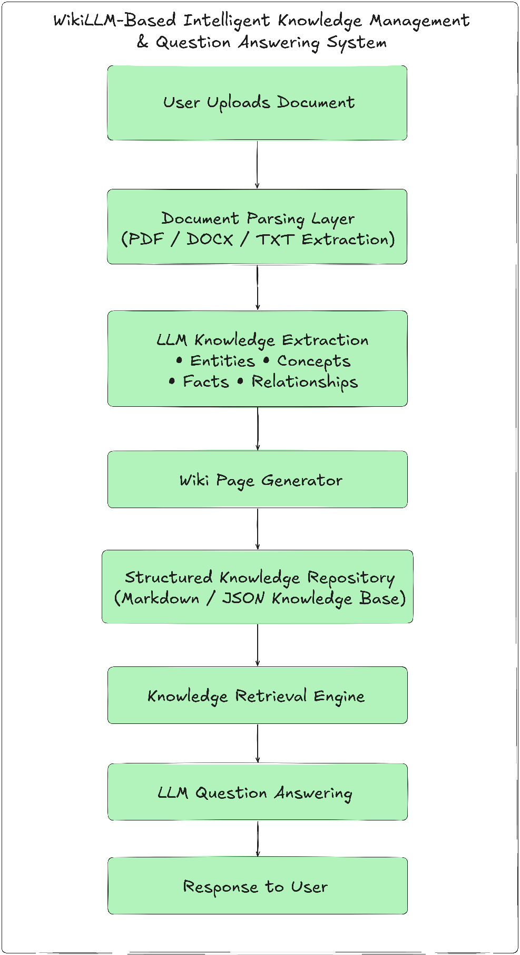

Proposed Workflow
- Step 1 - Document Upload
Users upload one or more documents (PDF, DOCX, or TXT).

- Step 2 - Document Parsing
The system extracts readable text from the uploaded document while preserving document structure where possible.

- Step 3 - Knowledge Extraction
Using an LLM, the system identifies:
  - Important entities
  - Key concepts Definition
  - Facts
  - Relationships between entities
  - Important summaries
The extracted knowledge will be converted into structured JSON.

- Step 4 - Wiki Generation
The extracted knowledge is automatically converted into wiki-style pages.
Example: Tesla.md / Overview / Founder / CEO / Products / Related Topics / [[Electric Vehicles]] / [[Battery Technology]]
(Each page will contain references to related topics to create an interconnected knowledge network.)
- Step 5 - Knowledge Storage
Generated wiki pages will be stored in a structured repository.
Possible formats include:
  - Markdown
  - JSON
  - SQLite metadata
- Step 6 - Question Answering
When a user submits a question:
  - Relevant wiki pages are identified.
  - Related linked pages are collected.
  - Context is sent to the LLM.
  - The LLM generates the final answer

5. Key Features
- Document Upload
- Automatic Knowledge Extraction
- Entity Recognition
- Relationship Detection
- Wiki Page Generation
- Linked Knowledge Pages
- Natural Language Question Answering
- Multi-document Support
- Persistent Knowledge Base
- Easily Extendable Architecture

6. Proposed Technology Stack
Component | Component Technology
Programming language | Programming Language Python
Backend | Backend FastAPI
Llm framework | LangGraph / LangChain
Llm | OpenAI GPT
Document parsing pymupdf | PyMuPDF
Knowledge storage | Markdown + JSON
Metadata storage | SQLite
Optional semantic search | ChromaDB
Version control | Git

7. Deliverables
The completed project will include:
- Web interface
- Source Code
- Project Documentation
- System Architecture Diagram
- Sample Knowledge Base
- Demonstration with Sample Documents
- Question Answering Demo

